## Top 5 visibility of the Balkan area

In this paragraph we explain how the top 5 visibility of the Balkan area is implemented.

All the logic of the view is implemented in the Top5Visibility controller. Because there is so much data and we want to view it as fast as possible we make use of excel files. In this certain view we decided to calculate an average for the previous days and add this in a database because there wouldn’t be any changes anymore. The current day is calculated again because there can be new added data. Because of this feature the previous days load a load quicker which improves the user experience.

A couple of routes are registered;

* /top5visibility/{requestDate?} calls the home() function
* /top5visibility/{date}/live/data calls the getData() function
* /top5visibiliy/{date}download calls the downloadData() function.

**Home() function**

The home function in the controller requires a requestDate variable. This date is checked if it contains data and is converted and checked for the right time format. The time format we decided earlier is yyyy-mm-dd. We call the calculateData() function and calculate the data for a certain date. The result is parsed to the view. Afterwards the view decides what to do with the information.

**getData() function**

This function calls the calculateData() function and convert the resulted array to a JSON format. The JSON data is outputted at top5visibility/live/data. Because of this format we can easily read the data in the view with javascript.

**calculateData() function**

This function receives the data from a certain day by reading a csv file from the disk. It reads the filenames based on the time and date structure. Because the directories are structured in a yyyy-mm-dd structure we can easily open the right files which saves a load of loading time. All the files that correspond to the selected data are opened and parsed.

The parsing reads every new line and adds the visibility of this line to the visibility variable. A counter is also updated.

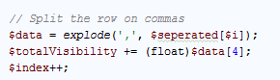

When the parsing is done the data is implemented in a database table called ‘Avarage visibility’.

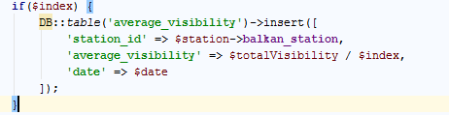

**downloadData() function**

Parses data from a certain date to a csv file. The logic is explained in another paragraph.

**The view**

The view contains a visualization(bar chart) that shows the data that is calculated.

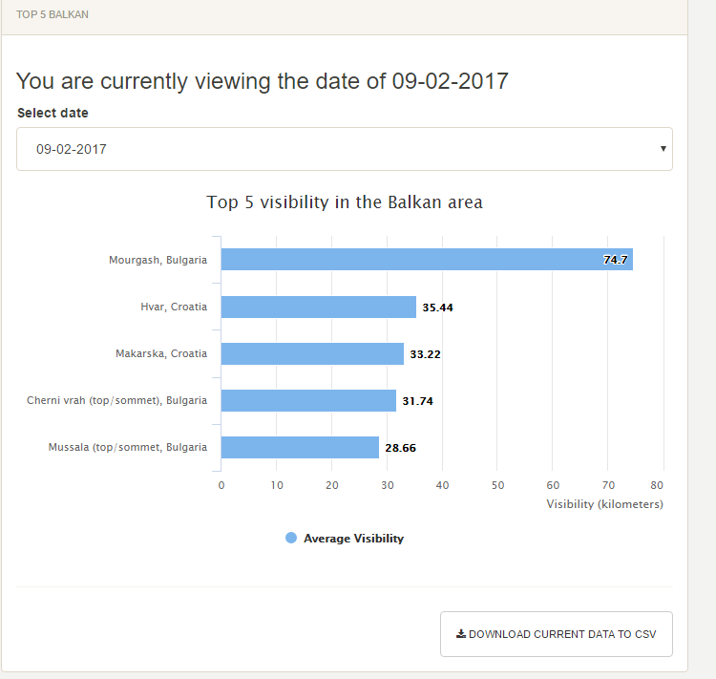

For the more technical readers out there u can view the source code. The code is also well documented.

The logic is available at:  
<https://github.com/emachiels/Project-2.2/blob/develop/website/app/Http/Controllers/Top5visibilityController.php>

The view is available at:  
<https://github.com/emachiels/Project-2.2/blob/develop/website/resources/views/top5visibility.blade.php>

## Windows, Linux difference

Because Linux and Windows use different code for line breaking we implemented a function that checks which OS is running. Based on the OS running it changes some code parts so it works om multiple systems.